13. Web Service using AJAX

Imports System.Web.Services

Imports System.Web.Services.Protocols

Imports System.ComponentModel

' To allow this Web Service to be called from script, using ASP.NET AJAX, uncomment the following line.

' <System.Web.Script.Services.ScriptService()> _

<System.Web.Services.WebService(Namespace:="http://tempuri.org/")> _

<System.Web.Services.WebServiceBinding(ConformsTo:=WsiProfiles.BasicProfile1_1)> _

<ToolboxItem(False)> _

Public Class WebService3

Inherits System.Web.Services.WebService

<WebMethod()>

Public Function HelloWorld() As String

Return "Hello World"

End Function

<WebMethod()>

Public Function add(x As Int16, y As Int16)

Return x + y

End Function

<WebMethod()>

Public Function subtraction(x As Int16, y As Int16)

Return x - y

End Function

<WebMethod()>

Public Function mul(x As Int16, y As Int16)

Return x * y

End Function

<WebMethod()>

Public Function div(x As Int16, y As Int16)

Return x / y

End Function

End Class

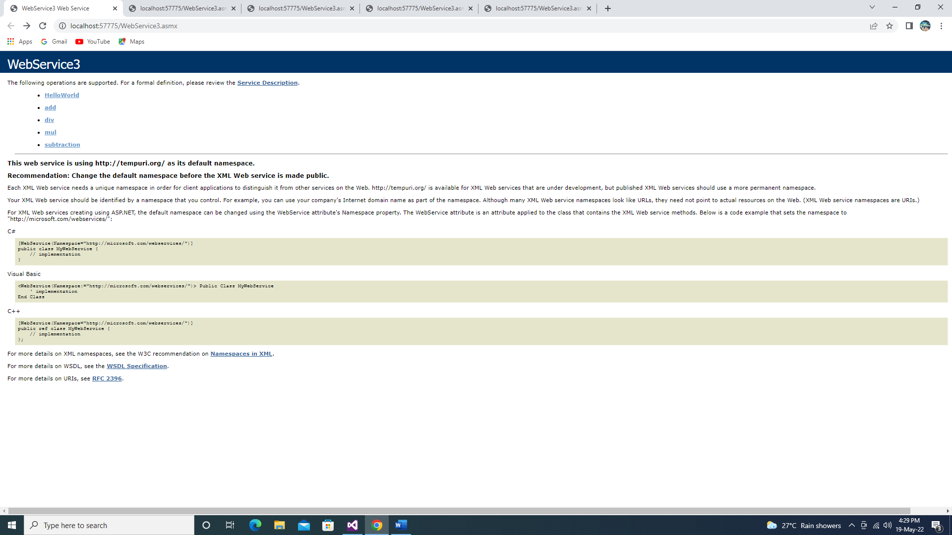**Output**

